**FUNCTIONS AND INVERSES NOTES 22/02/2025**

**ARE THE FOLLOWING FUNCTIONS OR NON-FUNCTIONS**

1. **(1 ; -2) ; (5 ; 3) ; (15 ; -2) ; ( 6; 8) ---- Function**
2. **(11 ; 12) ; (51 ; 3) ; (15 ; -2) ; ( 51; 8) ---- Non Function**
3. **(1 ; -2) ; (5 ; 3) ; (15 ; 12) ; ( 6; 8) --- -Function**

* **IF ALL *X-*VALUES ARE DIFFERENT IT IS A FUNCTION**

**THE *Y* -VALUES CAN REPEAT ITSELF**

**EXAMPLE:**

For what values of a and b is the following a function:

(*a*; 3) ; (13 ; 7) ; (-5 ; 9) ; (7 ; *b*)

**Solution:**

*a*  ; a {13 ; -5 ; 7}

*b*  ;

1. **LINES OF SYMMETRY**

**RULES**

* ***x- axis*** ***(x ; y)(x ; – y)***
* ***y-axis*** ***(x ; y)(– x ; y)***
* ***y = x (x ; y)******(y ; x)***
* ***y = – x (x ; y) (–y ;– x)***
* **ORIGIN *(x ; y)(– x ; – y)***

**EXAMPLE:**

**Given:** 

1. 
2. **Sketch both **
3. **Determine the point of intersection of **

**Solution:**





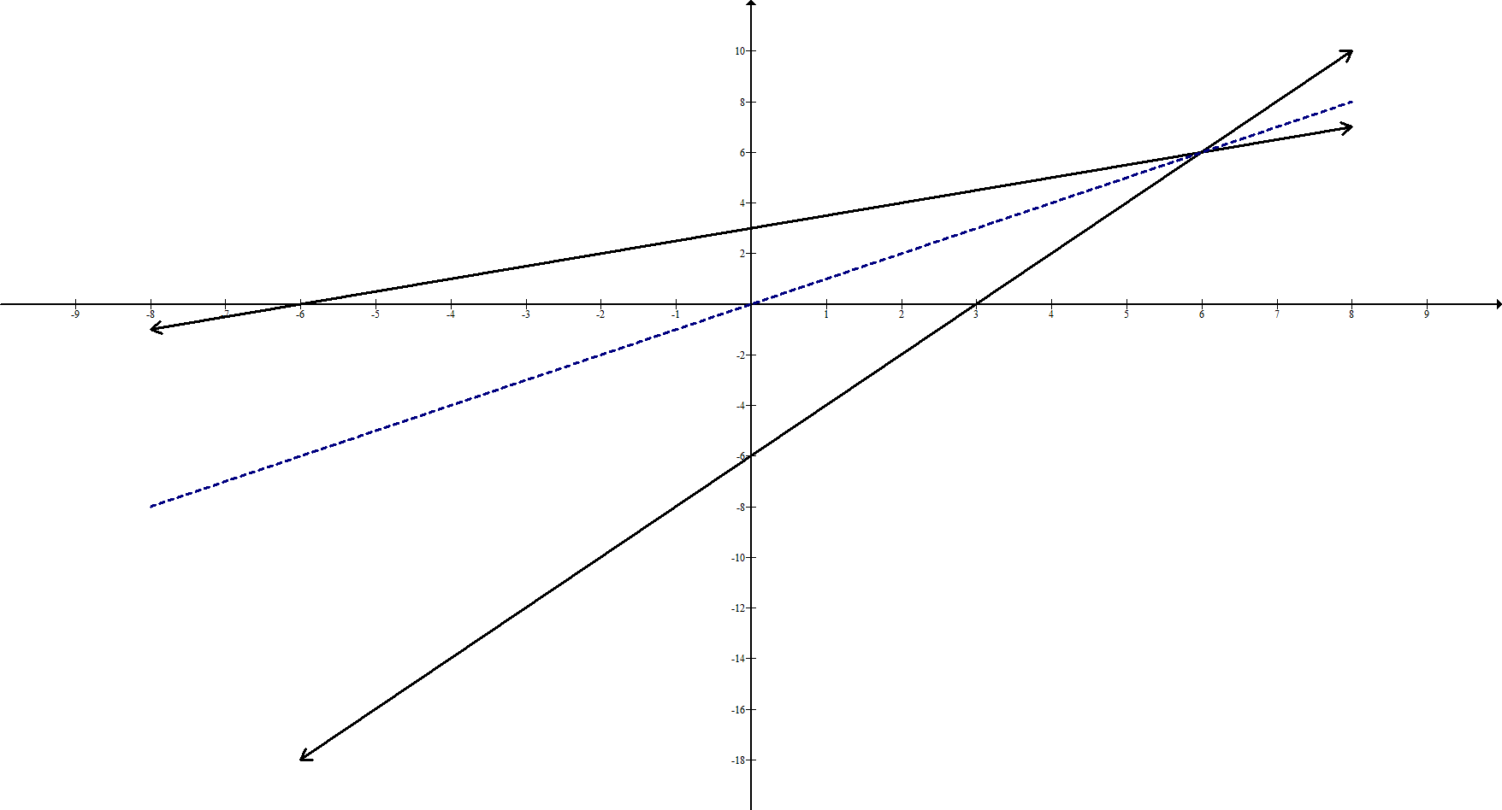

*y*

*x*

*y = x*

*f-1*

*f*





